

FIRE SAFETY POLICY

Ratified – November 2024

To be Reviewed – November 2026

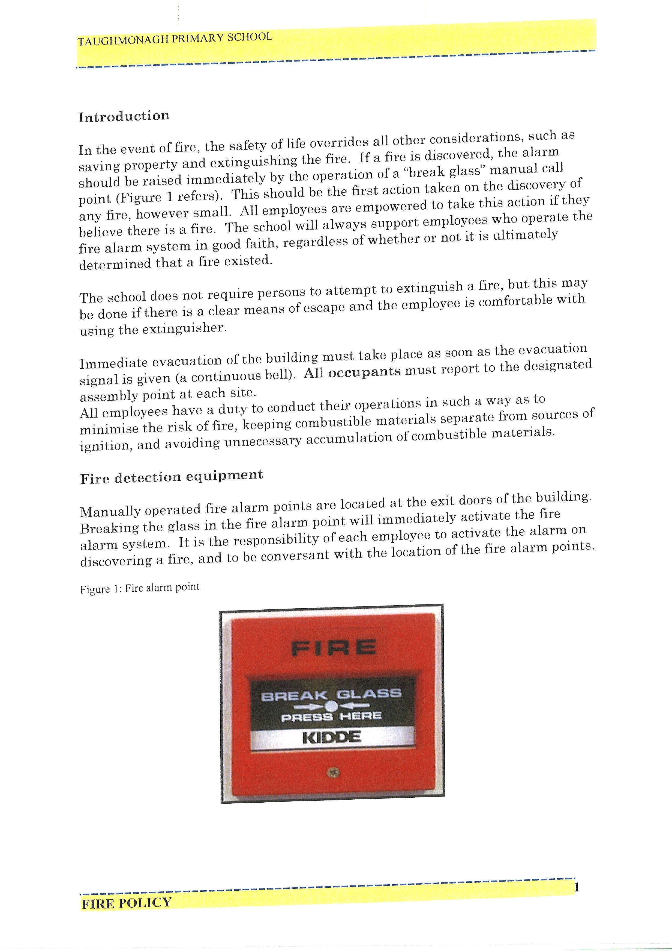

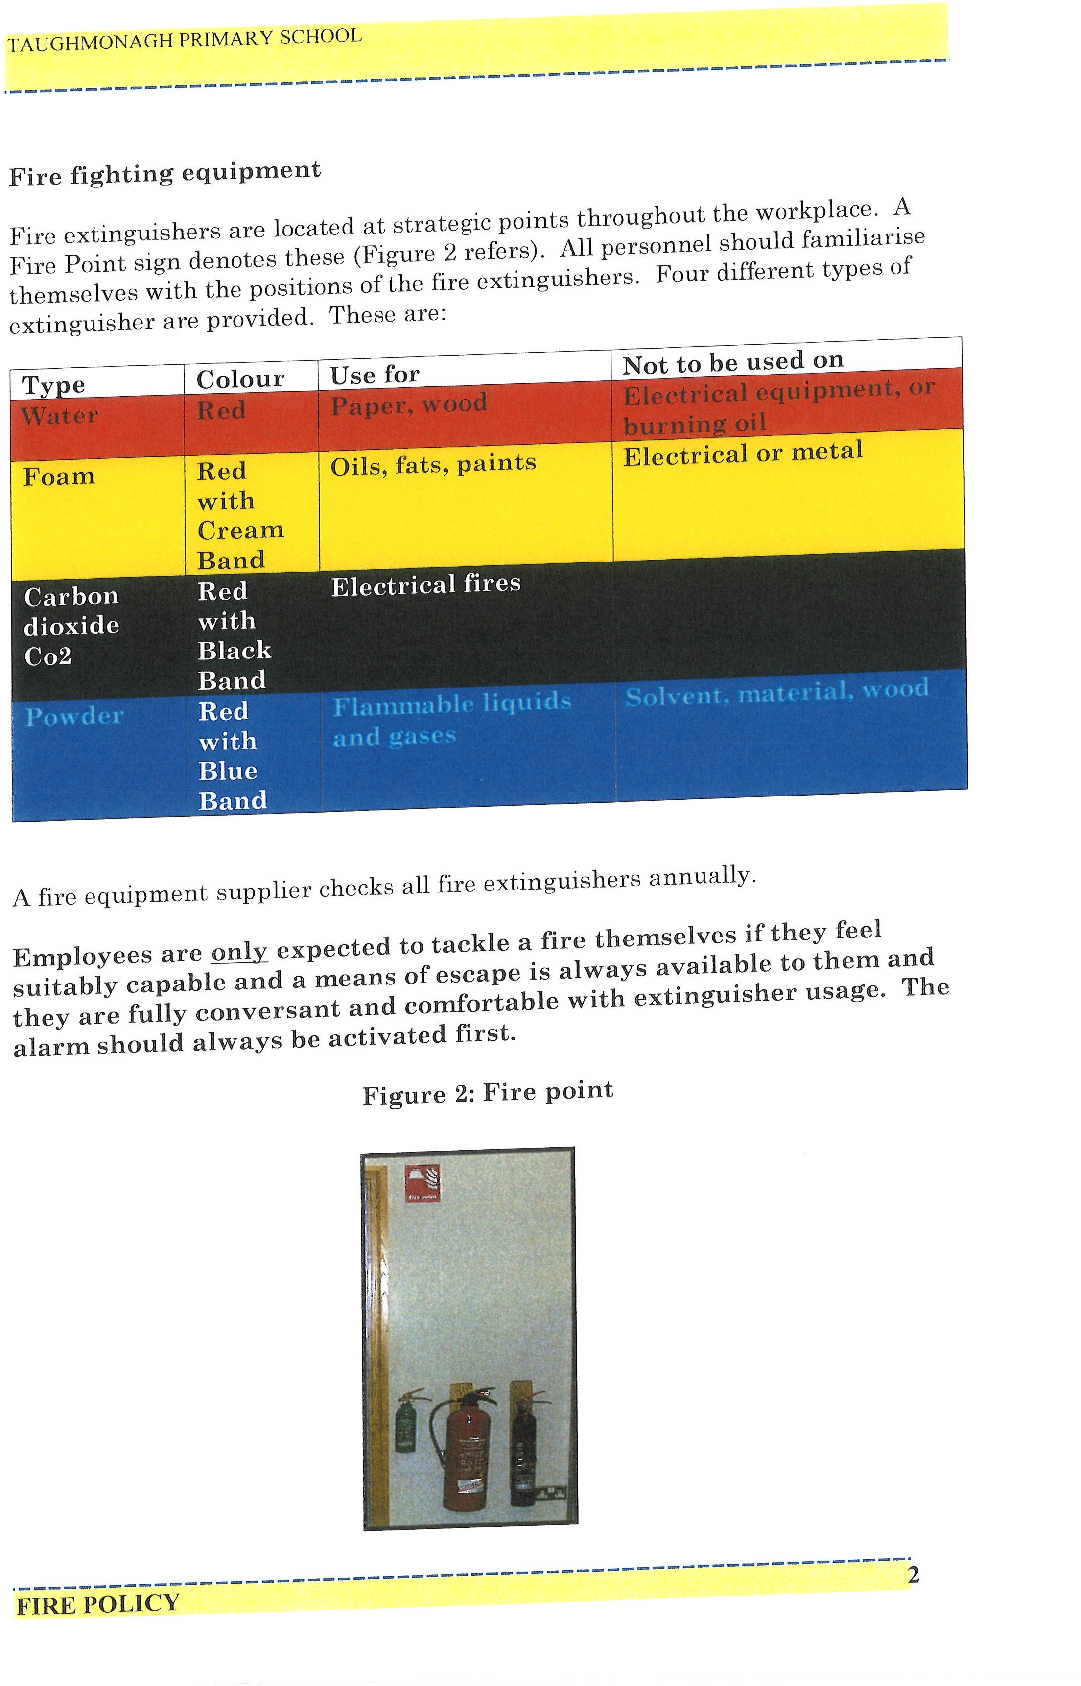

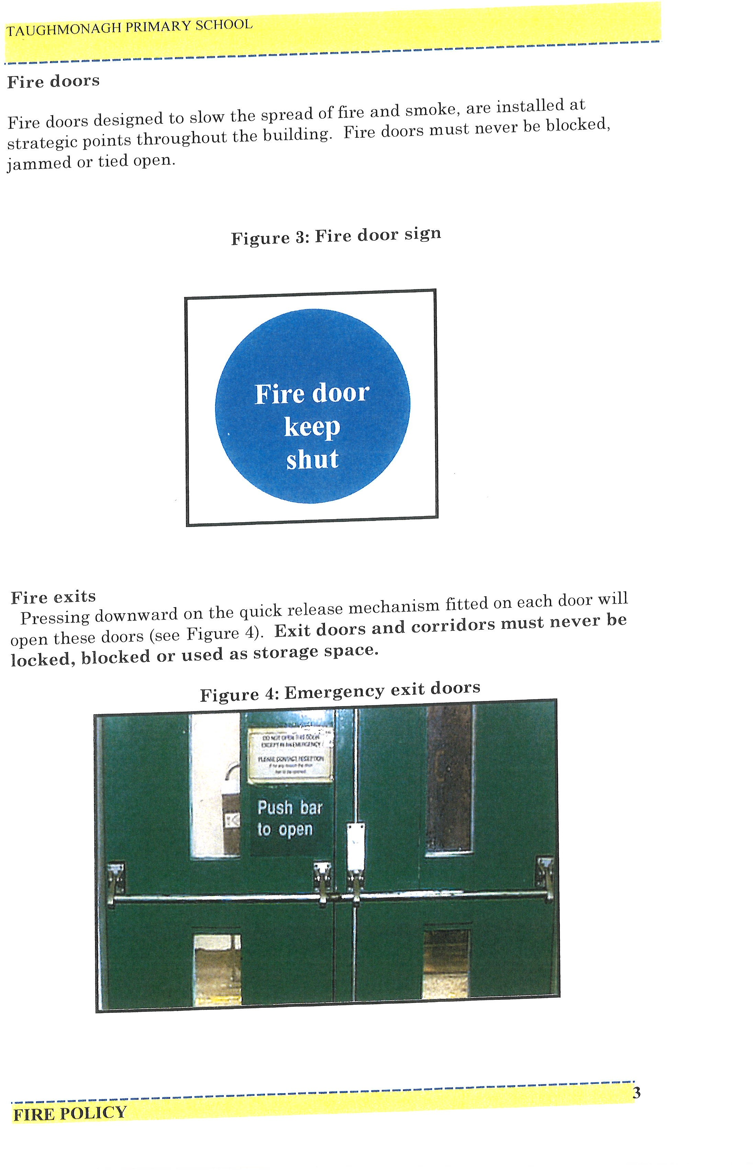

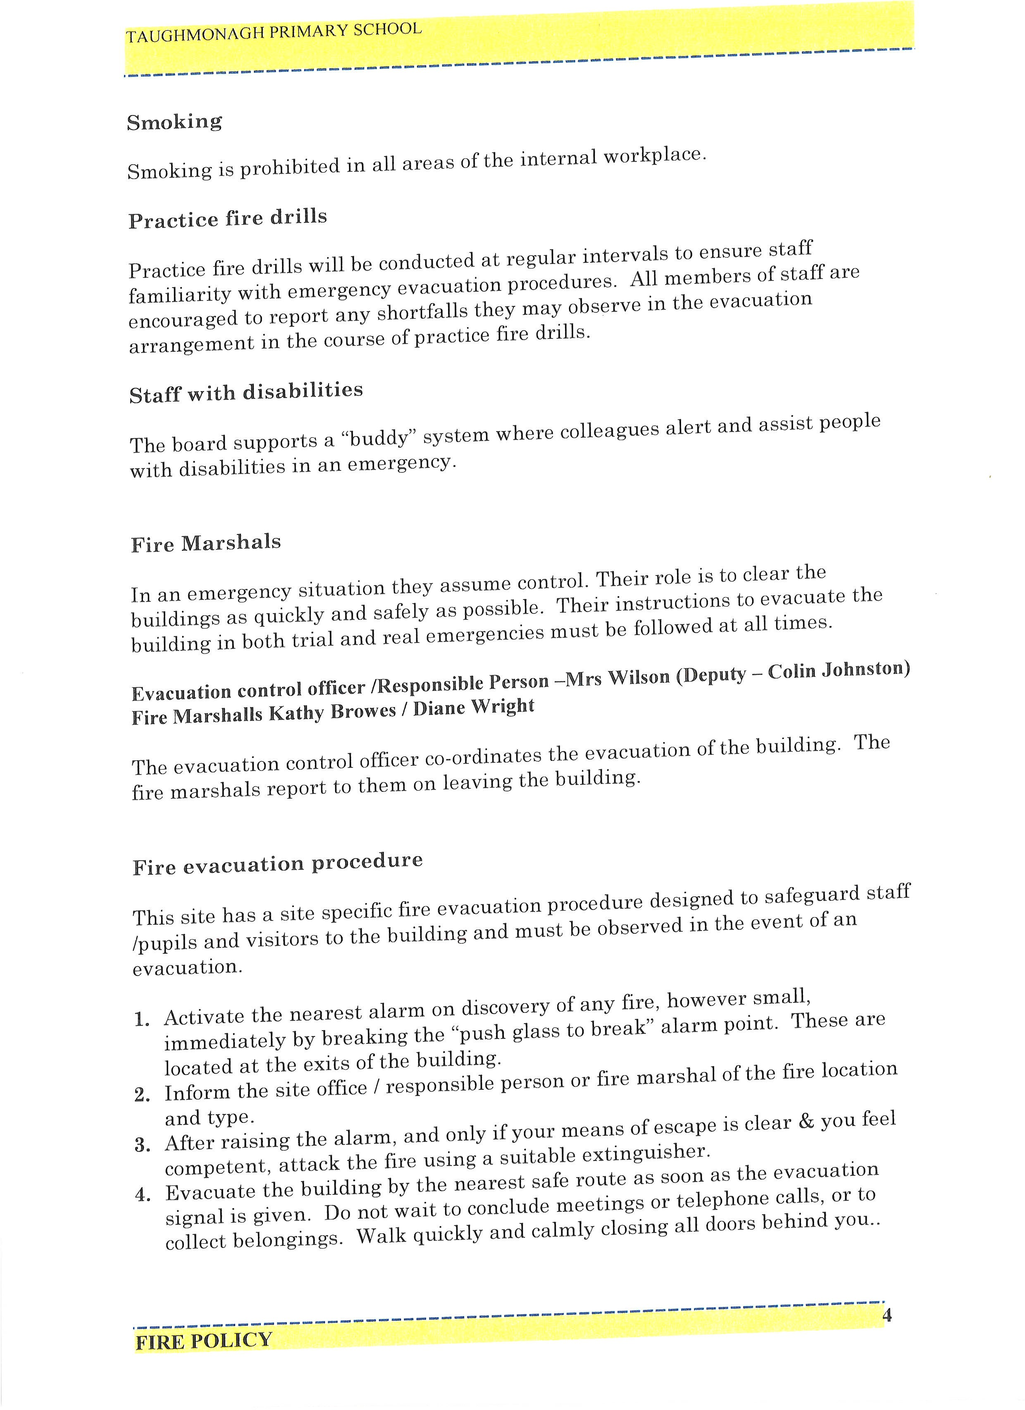

Evacuation control officer/ Responsible Person – Mrs Johnston (Deputy – Mt Todd)
Fire Marshalls - Mrs Watters, Miss Sayers & Mr Todd (All class teachers are Fire Marshalls for their own classrooms. Basic Fire Safety Awareness Training will be completed by all staff, annually
https://www.eani.org.uk/basic-fire-safety-awareness-training
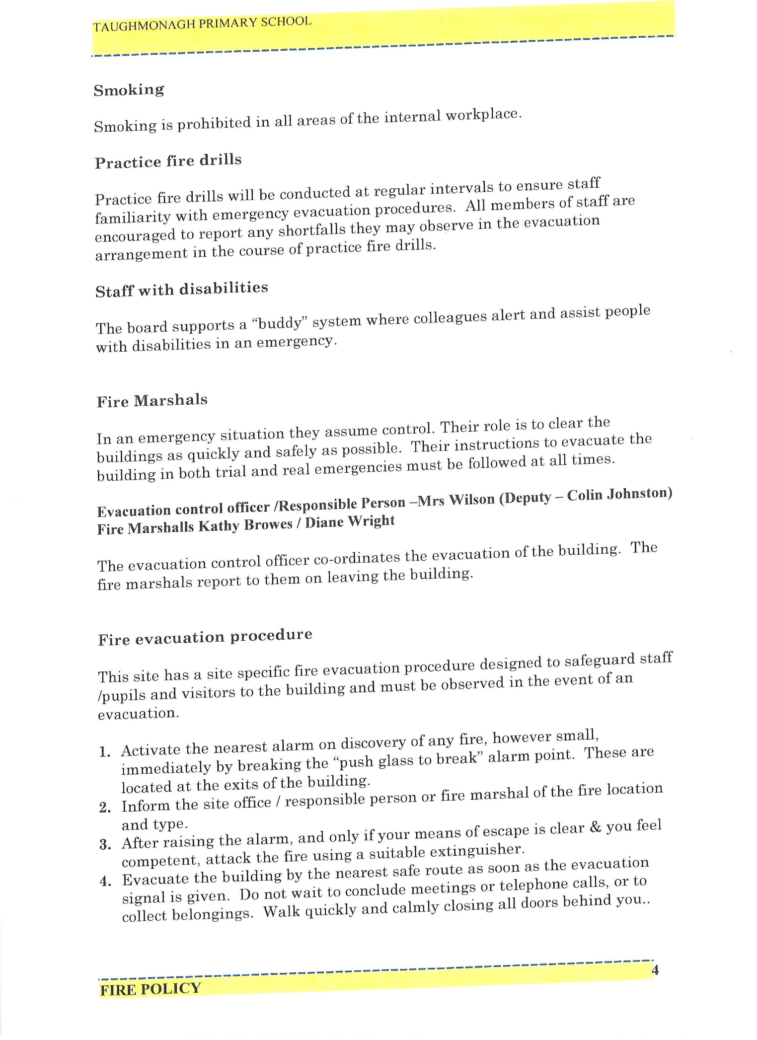

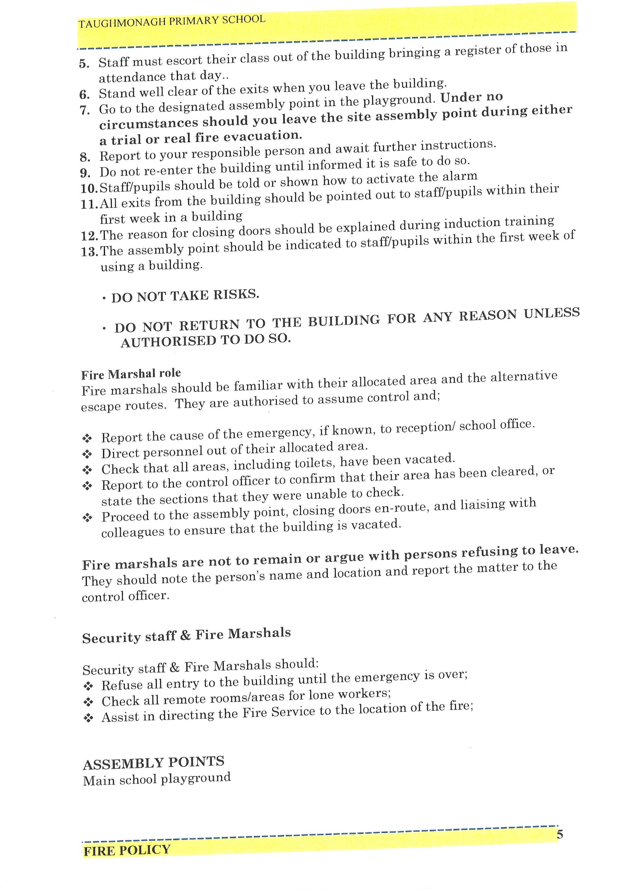

ASSEMBLY POINTS –
Nursery – Path outside Family Support Hub
P1, P2, P3, P3/4 – Use side exit at Foundation Stage classrooms and make way out to top playground
P4, P5, P7, SEN Room 1, Library – Use main double doors at reception and make way to top playground
Sunshine Room – Up stairs and out to top playground
P6, P6/7, SEN Room 2, Parents Room – Use stairs and exit at bottom door and make way to bottom playground

